24VAC

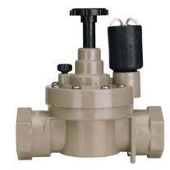

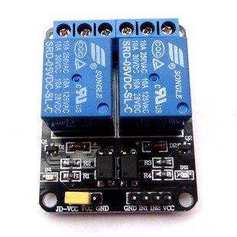

**Outlet**

**Relay**

**Pin 5**

**Inlet**

**Relay**

**Pin 6**

**Outlet**

**Solenoid**

**Inlet**

**Solenoid**

**Flush Push Button**



**Reading Status LED**

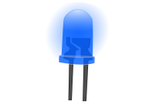

**Outlet Sol. Open**

**LED**

**Inlet Sol. Open**

**LED**



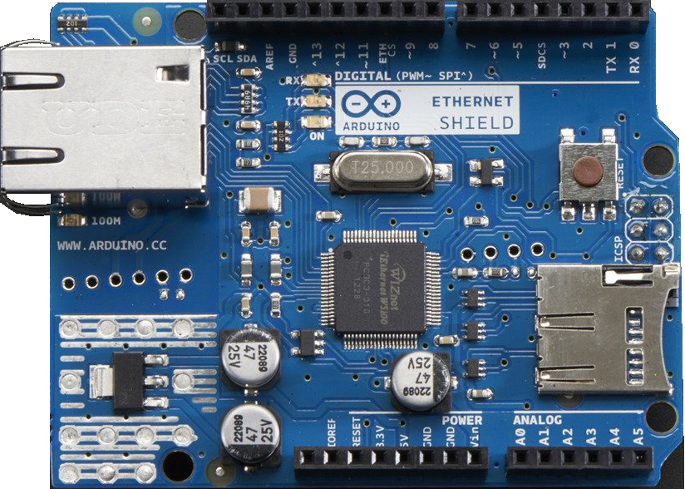

E

S

+



Network







Water Level Sensor



9VDC

